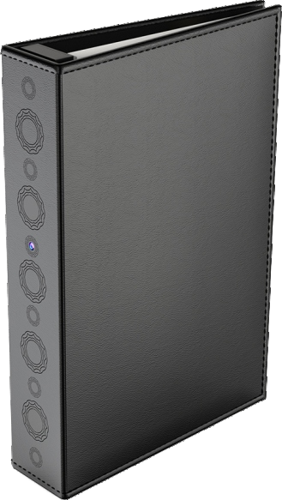
Model No.: DV9
DV9 Book Hidden Camera
User Manual

Table of Contents
Part 1 Before First Use..............................................1-2 Part 2 Quick Guide.......................................................3
Part 3 Detailed User Manual.....................................4-21
Part 3 Detailed User Manual
Safety precautions........................................................4
Warning on invasion of privacy.......................................5 What’s Included............................................................6
DV9 Diagram................................................................7
Before Using Your Conbrov DV9 Camera....................8-11
How to Use Your Conbrov DV9 Camera.....................12-14
1.Turning the Camera On/Off.....................................12
2.How to Record a Video ......................................12-13
3.How to Record with Sound.....................................14
4.How to Switch Into Night Vision ..............................14 5.How to Play the Video ...........................................14 LED status..................................................................15 Technical specifications...............................................16 FAQs.....................................................................17-18 Warranty.....................................................................19 Disposal......................................................................19
Declaration of conformity..............................................19

Part1 Before First Use

Charging the camera 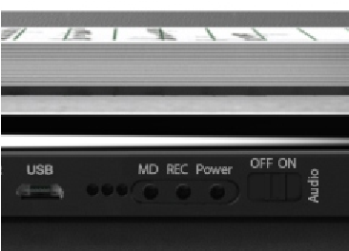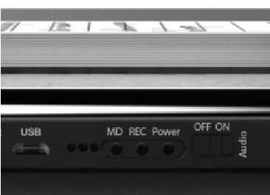Formatting the microSD card
Yellow indicator
Yellow indicator
Before the first use, charge the camera for about three to four hours via your PC or USB charger (we recommend using the "5V/1A" power adapter)
Before the first use, format the microSD card to FAT32 format (applicable to Windows system ONLY). The camera only supports class 10 microSD cards with at least an 8GB capacity. It supports cards up to 32 GB.
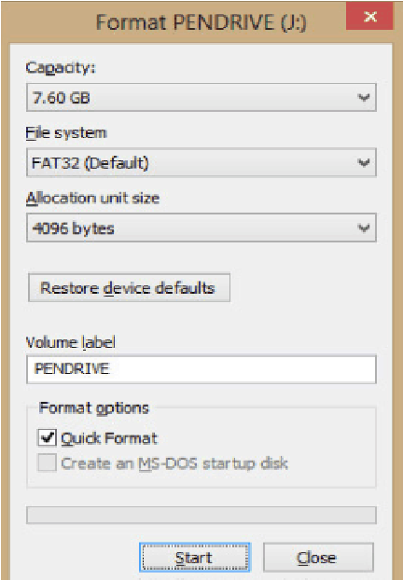

Part1: Before First Use

Resetting the camera
If the camera malfunctions for any reason, reset it with the included pin. A small paperclip can also be used.
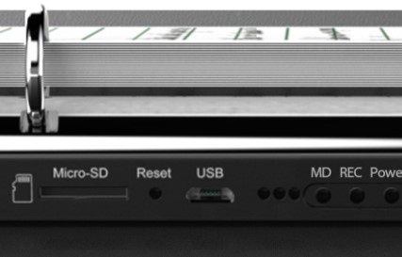

Part 2 Quick Guide
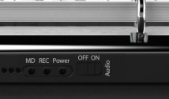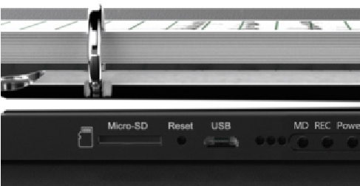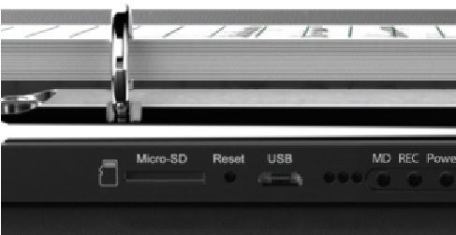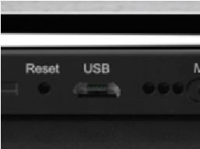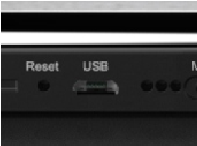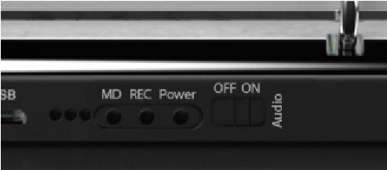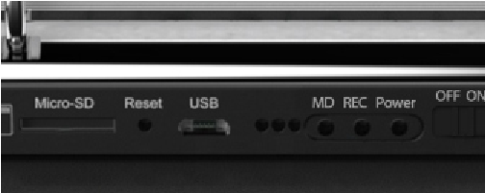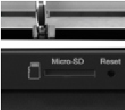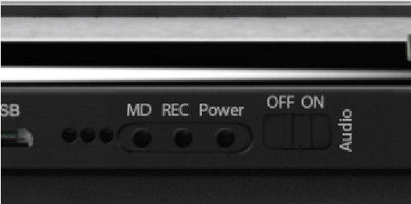
A.Install the microSD Card
B.Turn On/Off
C.Record A Video
D.
Play The Video
OFF
flashes
alternating red
and blue and then
turns off
Record a Video

flash 3 times blue
1
2
USB2
.
0
ON
lights up blue
and the camera is
in standby mode
2
S power on
For more detailed information, see Part 3: Detailed User Manual.

Safety precautions
Read this instruction manual carefully before using the camera. It contains important information for your safety as well as operating and maintenance instructions.
Follow all safety precautions in order to prevent damage due to improper use of the camera.
Keep this user manual carefully for future use. Should this camera be passed along to a third party, this user manual must be handed on as well.
Use the camera only for its intended purpose.
In the event of improper use or erroneous handling, no liability can be assumed for any possible damage which may occur.
Never try to repair the camera yourself. Only allow qualified personnel to repair the camera in the event of malfunctions.
Warning! The camera is not waterproof.Never immerse the camera in water or other liquids while cleaning or operating it.
Do not open the housing under any circumstances. Do not introduce any metal objects into the interior of the housing.
Never use accessories which are not recommended by the manufacturer.
Keep the camera away from all hot surfaces and naked flames. Protect the camera from extreme heat and cold, dust, direct sunlight, humidity and drops or jets of water.
Do not place any heavy objects on the camera.The manufacturer is not responsible for any missing video data due to maloperation, microSD card malfunctions, camera angle limitation, etc.

Warning on invasion of privacy
The camera should be used for legal purpose only. Follow the laws of your country.
Recording and circulating an image of an individual may constitute an infringement of their privacy for which you could be liable. Ask for authorization before filming individuals, particularly if you want to keep your recordings and/or circulate images on the Internet or any other medium. Do not circulate a degrading image or one which could undermine the reputation or dignity of an individual.

What's included
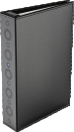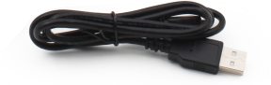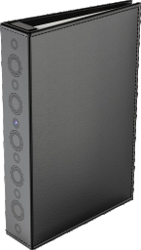
Model No.: DV9
DV9 Book Hidden Camera
User Manual
USB cable
Camera
User manual
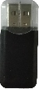
Pin Waring sticker Card reader

DV9 Diagram
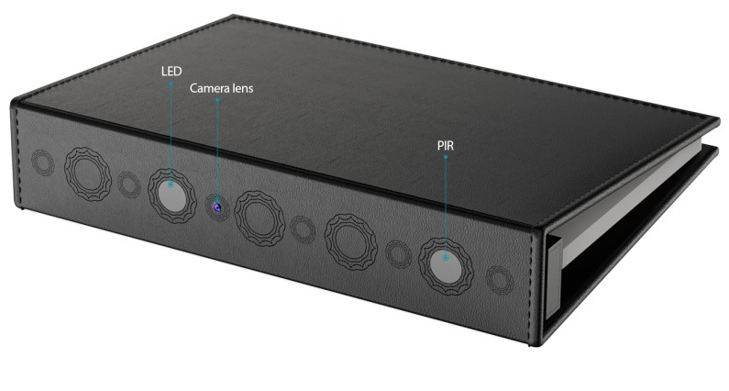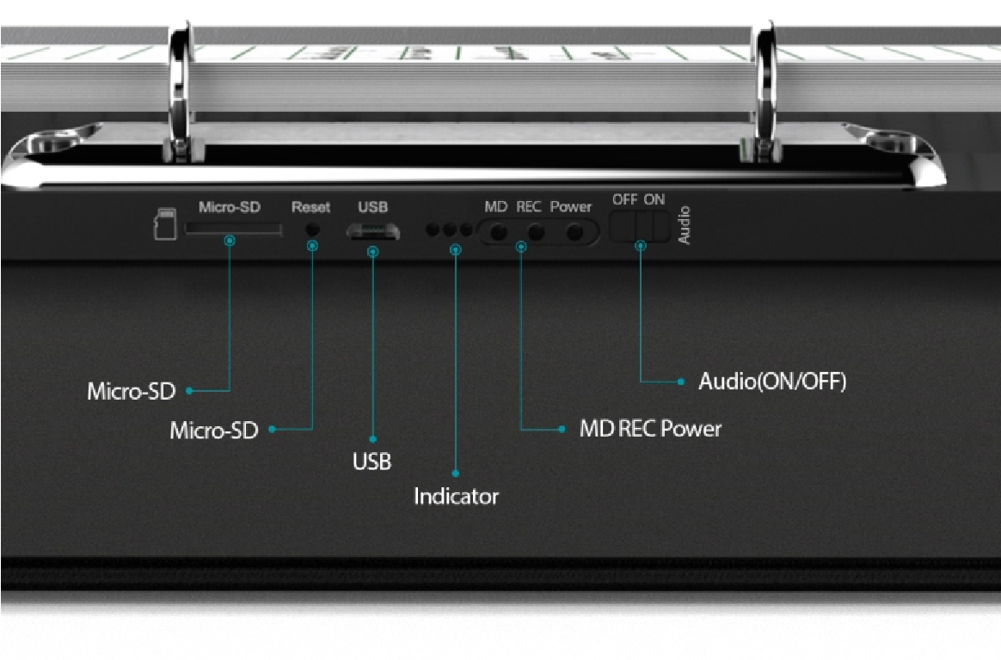
60
PIR Detection Angle
Camera Lens (75 Camera Angle)
LED

1. Charging your camera
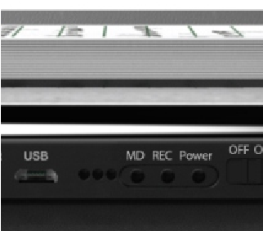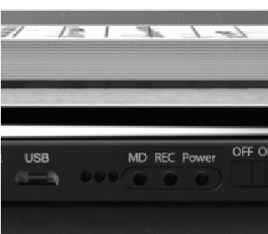
Off
Steady yellow
Off
Flashing blue and red
Charging
Fully charged
Low power
Yellow indicator
- Make sure the camera is OFF before charging.
- Plug the USB cable both in the camera and in a computer USB port or a 5V/1A adapter (not included). The yellow LED is on while charging. The charging time is more than 10 hours.
- The yellow LED turns off when the camera is fully charged.

2. Installing the microSD card
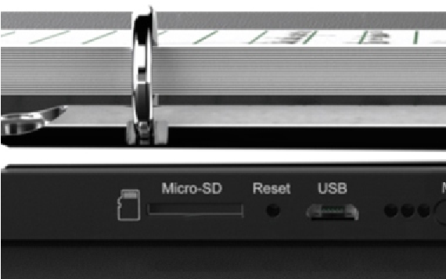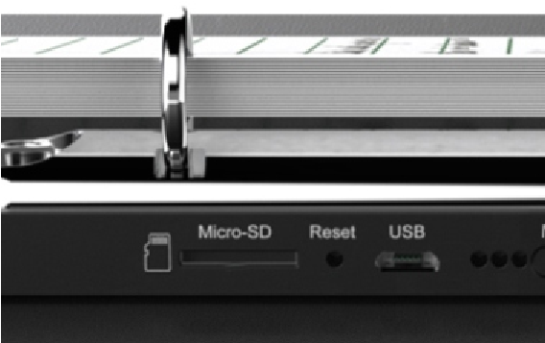
Installing the microSD card Removing the micro SD card
Caution! Format the microSD before using. Doing this, however, will remove all data from the card. Make sure to back up data before formatting (applicable to Windows system ONLY).
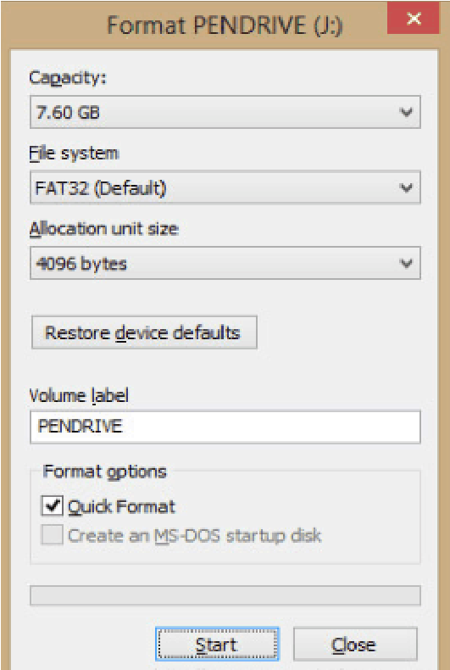
- The device supports a Class 10 microSD card which has capacity of more than 8GB and up to 32GB.
- Do not remove the microSD card during operation. it will damage both the memory card and camera.
- Push the microSD card into the slot gently until it clicks into place.The card only fits one way, so do not force the card into the port.
- To remove the microSD card, make sure the camera is OFF. Press down on the microSD and it will pop up,you can then pull it out easily.

3.Setting the date and time
Turn on the camera and connect it to a PC with the included USB cable. After a few seconds, the microSD card will be shown as a removable disk, then open SETTIME.TXT file.
SETTI
M
E
Open the SETTIME.TXT file,The following menu will be displayed:
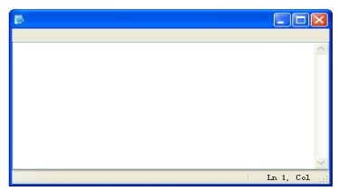
File name Time format: yyyy-mm-dd, hh:mm:ss yes: loop recording on microSD no: no loop recording
SETTIME.TXT
file Edit Format View Help
2016-07-15
,

23:59:59
yes
Modify the date and time on the computer.After setting date and time, click on “File” and then on “Save”.
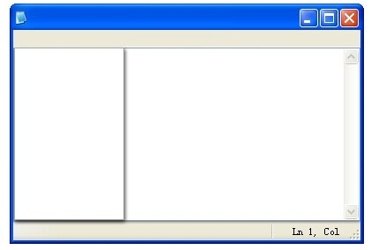
New
Open
Save
Save as
Page settings
Print
Exit
File
Edit Format View Help
SETTIME.TXT
Note: If you cannot find the file SETTIME.TXT after opening the microSD on the computer, please record a video clip to activate the card and set the date and time again. The date and time will remain accurate unless the battery has been depleted for long time.

1.Turning the Camera On/Off
- Press and hold the Power to switch the camera on. The LED will light up blue, which indicates that it is in standby mode.
- Press and hold the Power to switch the camera off. The LED will flash alternating red and blue and then turn off.
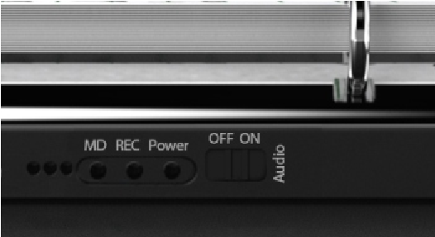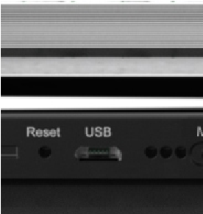
OFF
flashes
alternating red
and blue and then
turns off
ON
lights up blue
and the camera is
in standby mode
Note: If the camera switches off automatically, there are two reasons:
- The battery power is too low and the camera must be charged.
- The camera has been in standby mode without any operation for longer than 1 minute. In this case, the camera switches off to save battery power.

2. How to Record a Video
- Continuous Manual Recording(Press REC after the camera is powered on)
Press REC, the blue LED will flash 3 times and then go off. A 10-minute video clip will be recorded.
Press REC again, the blue LED will be on. The device will save the video to the microSD card and stop recording .
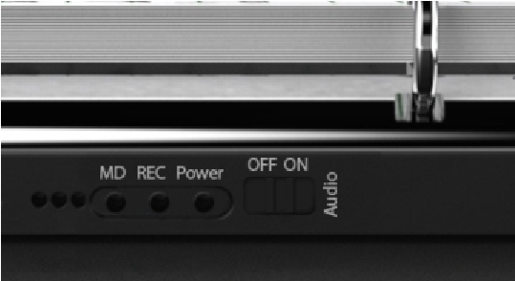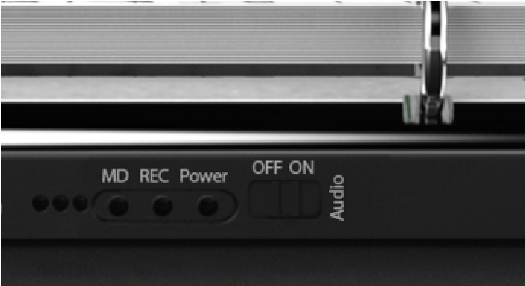
Record a Video

flash 3 times blue
- Motion Detection Recording (Press MD after the camera is powered on)
When motion detection is activated, recording will begin when there is movement in front of the camera(not further than25 feet).The motion sensor detects the environment every 1minutes.The camera will begin recording again when it detects new movement.
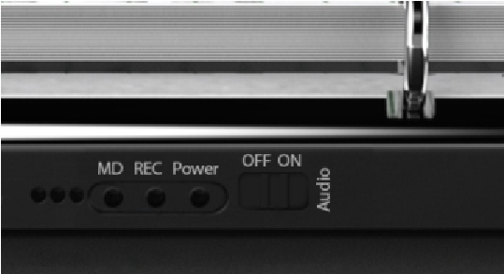
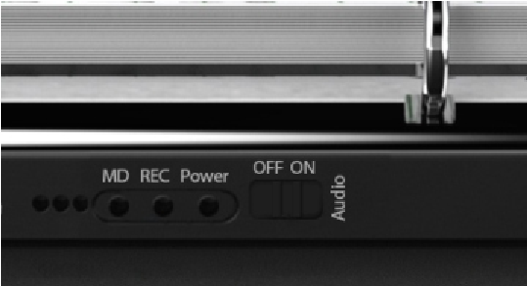
The red LED indicator is always on when in motion detection mode. the camera will enter into 1-minute test recording; after that, the PIR motion sensor is triggered while detecting a motion, the blue LEDs light up and go off, then the 2nd & 3rd red LEDs flash and go off (the 1st red LED always stays on), the camera begins to record video.
Press
button, the 2nd & 3rd red LEDs flash and go off,
MD
Press MD again, the blue and red LEDs light up then go off. The camera will save the video to the microSD card and stop recording.

3.How to Record with Sound
Before recording, push the button to AUDIO ON if you want to record a video with sound; if not, please push the button to OFF.
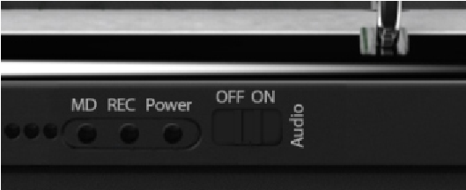

4.How to Switch Into Night Vision
Whether under manually recording or PIR activated recording, when ambient light brightness is lower than 10LUX, the camera will automatically switch into night vision and the video is black and white.

5.How to Play the Video
- Connect the DV9 camera to computer, press and hold the Power button for 2 seconds to tum on the camera or take out the microSD, insert it into the card reader (included), then connect the card reader to computer.
- After a few seconds, there will be a removable disk shown on computer. Open it, and then you'll see a Video file. Open it to play videos.
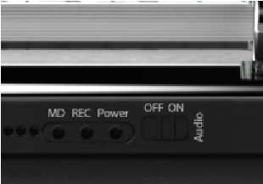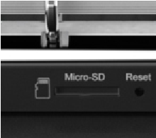
1
2
USB2
.
0

LED status
Operation LED status indication
Power On  (Press and hold the Power button  for 2 seconds) | Normally the blue LED indicator will stay on.
 | If no microSD, the blue LED flashes for 10 seconds then powers off.
 | The camera powers Off after 60 seconds if there is no any operation.
Continuously recording  (Press REC after power on) | Press REC, the blue LED indicator will automatically record for 10 minutes per file.  Press REC again, the blue LED will be on, save the present video and stop recording.
PIR motion detection recording (Press MD after power on) | Red LED indicator always on.
 | When there are people moving, the blue LED indicator turns On and then goes Off. The red light flashes and goes Off (the first red light will stay On) Now the camera will record the present motion and save a video to the microSD card.
 | Press MD again, the blue and red LEDs flash and go off. The camera will save present video, quit MD and power off.
Charging | The yellow LED stays On during charging; once the camera is full charged, it will go Off.
Power Off  (Press the Power button for a few seconds) | LED flashes alternately red and blue, then off.

Technical specifications
Item | Parameter
Dimensions | 21*15*4CM
Net weight | 415g
Battery Capacity | 10000mAh
Stand-by power consumption | 10uA
PIR detection angle | 60 degrees
PIR detection distance | 5-8 meters
Camera angle | 75 degrees
Max PIR stand-by time | 2 years
Day time recording power consumption | 220 mA
Max day time recoridng  time | about 30 hours
Night vision recording power consumption | 820 mA
Max night vision  continuously recording time | 9-10 hours
Full charging time | more than 10 hours
Resolution | 720PFPS 30FPS
PIR motion detection recording | about 1 minute per file
Continuously recording | about 10 minutes per file
Maximum memory card extension | 32GB
Loop recording | optional

FAQs
- Q: "The battery standby time up to 2 year when the camera is fully charged." Do you really mean 2 years? or 2 days?
A: It's two years! This camera has a 10000mAh built-in rechargeable battery. When it is in motion detection mode, the battery standby time up to 2 year because it consumes a little power.
- Q: Is it a wifi camera?
A: No it's a traditional book hidden camera. It is easy to use and better protect your privacy. There are no complicated wifi connection steps.
- Q: Why can't I play back the video on computer? A: If you use a Mac, please try a VLC player.
If you use a Windows computer, please try KMP player. Sometimes, it is the problem of the media player.
- Q: How many hours of footage can be recorded on a 32G microSD card?
A: About 5-6 hours of footage can be fully recorded on a 32G microSD card in continuous manual recording mode. It records several 10-minute clip videos which are up to 1G maximum per clip.
- Q: The camera records in black-and-white or in color? I see a customer said it's only black and-white.
A: The camera records in color at day time, but in black and white when the ambient light brightness is lower than 10 LUX.

FAQs
- Q: I don't know why the video file can't be viewed? A: Please connect the camera to a computer via the included USB cable and power on. The microSD card is recognized and shown as a removable disk.
- Q: Is it compatible with Windows 10? A: Yes,no problem.
- Q: Does a 64Gb microSD card work with this camera? The user manual said it works only up to 32Gb microSD card.
A: The software version for this Conbrov book camera supports a microSD card up to 32Gb. We will inform you if we upgrade it to 64Gb later.
- Q: In the motion detection mode, why does the camera record hundreds of short videos when no movement in front of PIR sensor?
A: Please reset the camera and format the microSD card, then retry again.
- Q: Why I can't set the date and time?
A: Firstly you need record a video to activate the microSD card, connect the camera to computer; open the removable disk and the SETTIME.TXT file to set the date and time.

Warranty
All products sold by the Conbrov Group are covered by a 12-month full replacement warranty.
Happy with it? Share your experience with an Amazon review. Or any questions?
Our friendly customer services team are ready to
help: support@conbrov.com
Contacting us via the above email address is the quickest way to reach our support team.
For the electronic user manual and more information, please visit:

Disposal
Electrical products should not be discarded with household waste. According to the European Directive 2012/19/EC on waste electrical and electronic equipment and its implementation into national law, electrical products used must be collected separately and disposed of at collection points provided for this purpose. Talk with your local authorities or dealer for advice on recycling.

Declaration of conformity
Conbrov Electron Co., Ltd., Room 908 Huiyicaifu Center, c/o Queshan and Longhua Roads, Shenzhen, China, declares under our sole responsibility that the product Starlight Mini Camera T16, to which this declaration relates, meets all relevant European standards and directives. For the complete declaration of conformity visit our website www.conbrov.com.

Trademarks
All trademarks or registered trademarks are the property
of their respective owners.

Manufacturer
Conbrov Electron Co., Ltd.
Room 908 Huiyicaifu Center,
c/o Queshan and Longhua Roads
Shenzhen, People's Republic of China
About Us
Conbrov Electron Co., Ltd. founded in 2003 is an innovative
technology research company specialized in personal
surveillance cameras and on-dash cameras. Conbrov products
and technology are patent protected by PCT or U.S. Patent
Office. Based on years of professional experience and
knowledge, we are able to provide the best and most efficient
products and customer service.

